User Manual: ASI AnyWhere

| May-20 |

**Document Overview**

**Documentation Goals**

***Give your business and your salespeople a competitive advantage.*** This documentation is intended to provide instruction for the ***ASI AnyWhere*** system.

**Documentation Disclaimers**

* Teach a user how to utilize the *ASI AnyWhere* web-based system.

**Table of Contents**

**ASI AnyWhere Overview** 3

Available Functions 4

Security Overview 5

Login ID and Password 5

List Orders 6

View Order 6

View Item 7

On Hand 7

On Order 8

Allocated 8

Miscellaneous Charges 9

Ship Notes 9

Order Total 9

**ASI AnyWhere Menu Maintenance** 10

Add New Menu Item 11

Delete a Menu Item 12

Dump a Menu Item 12

**ASI AnyWhere: Shopping Cart Application** 13

Order Entry 14

Order Entry Field Definitions 14

Finished Goods 16

Finished Goods Field Definitions 17

**ASI AnyWhere: Security** 19

Define Users and Access Their Rights 19

Saving New Users 20

Customers and Vendors per User ID 20

Group Maintenance 20

# **ASI AnyWhere Overview**

*ASI AnyWhere* is a 24/7 customer and external employee access to Advantzware. This powerful web-based software is a marketing and business tool that gives your business a competitive advantage.

*ASI AnyWhere* gives access anywhere, anytime via an internet connection to customers and outside employees – even from a web-based phone.

This application runs in real time, so the moment that you ship inventory, your client can immediately review the information.

However, your company administers the security for what features and screens that your client can view or use.

Available functions include:

* Estimating and Quotes
  + Corrugated Box Estimates
  + Folding Estimates
  + Request for Quotes via 3D Style Image
  + Reports for Estimates
* Order Processing/Order Entry
  + Updating & Adding Orders
  + Shipping
  + Query Orders
  + Reports for Orders
  + Order Backlog Reporting
* Inventory Reporting/Finished Goods
  + Item Inquiries
  + Reports for Finished Goods
* History of Sales and Management Highlights
* Access to Sharp Shooter
* Warehouse Management
  + Daily Transactions
  + Warehouse Reports
  + File Maintenance
* Contact Marketing
  + Contact Status
  + Contact Maintenance
* Bill of Lading Proof of Delivery
  + Review and Reprint Signed Bill of Lading
* Production Status Inquiry
* Sales Reporting
  + Review and Reprint Invoice Form in .PDF Format
* Account Balances
  + Credit History with Aged Invoices
* Email Confirmations

#### ASI AnyWhere Window

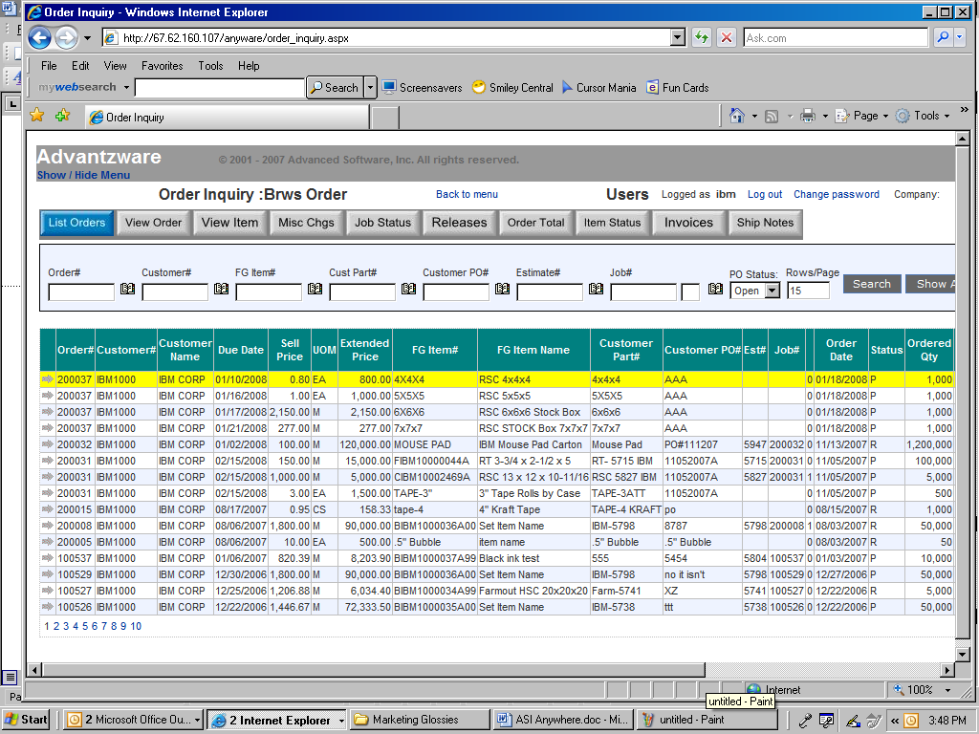

## Available Functions

The user may use the menu along the left side of the screen to choose which function they need to perform on *ASI AnyWhere*. The available functions are detailed as follows:

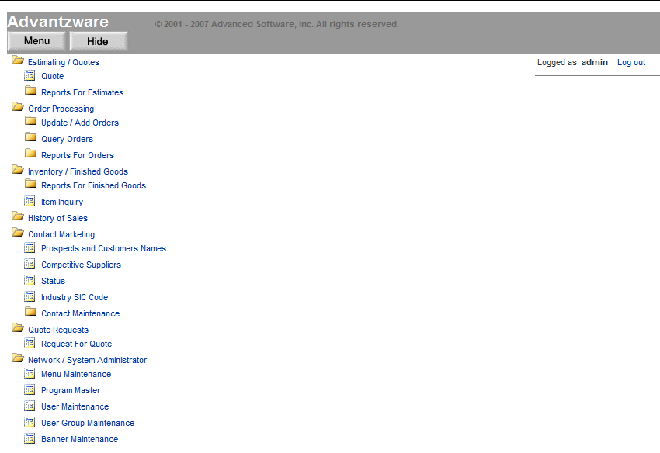

## Security Overview

The first step to implement *ASI AnyWhere* is to defined users and their access rights.

External users are limited to what they see as what changes they can make. Whereas an internal user such an outside salesperson or inside customer service analyst are only limited by security rights. Once defined, the login and password features protect your critical corporation information.

Underlying this security is the world-renowned Microsoft SQL Server database combined with the web security of Progress software’s application server, which allows 25 to unlimited users simultaneous access to information in real time.

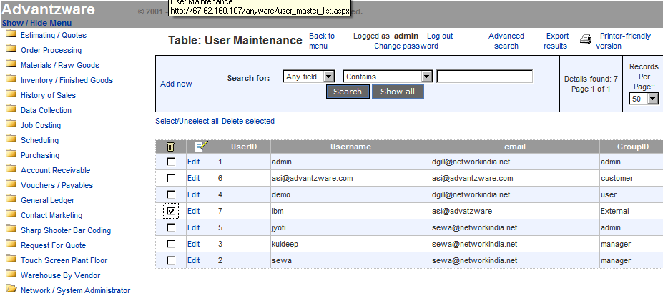

### Login ID and Password

The Login ID and password limits external users to only their customer information. The network security also limits what menu options are available by user.

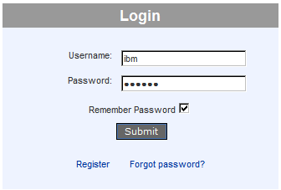

## List Orders

Orders may be found in a variety of ways. The more search criteria typed, the more refined the list of orders. For example, you may enter a specific order number, purchase order number, part number, estimate or job.

Likewise, the user can limit the search to open, closed or all the customer’s purchase orders. The yellow bar indicates which item is selected. Once an item is selected, all the buttons or folders at the top of the order browser will focus on that item until the user selects another item.

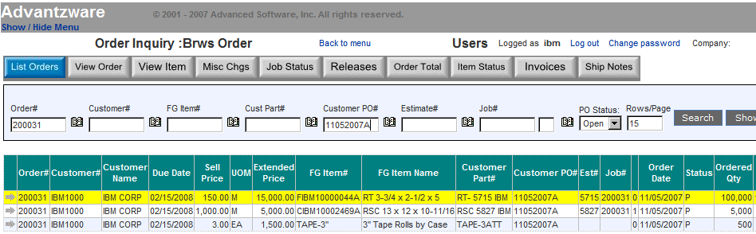

## View Order

The View Order screen shows general information about the order such as the customer that will receive the invoice, the location that the products were sold to and pertinent data such as the salesperson to contract.

Most information such as due date, purchase order number and shipping carrier may be changed for each item on the order or for each delivery release for the item.

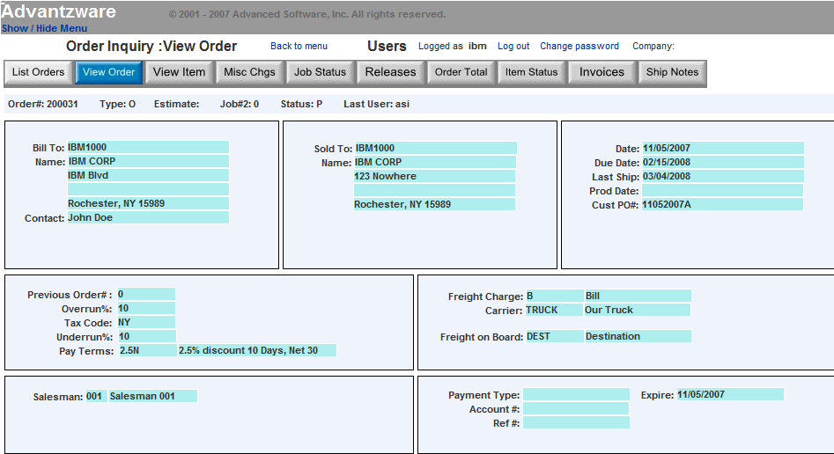

## View Item

The View Item screen shows all the items for a specific order. The yellow bar indicates which item is selected. Once an item is selected, all the button or folders at the top of the order will focus on that item.

The buttons at the bottom of the item screen called ***“On Hand”***, ***“On Order”***, and ***“Allocated”***, drill down to more detailed specifications. The ***“On Hand”*** button shows a list of exact location

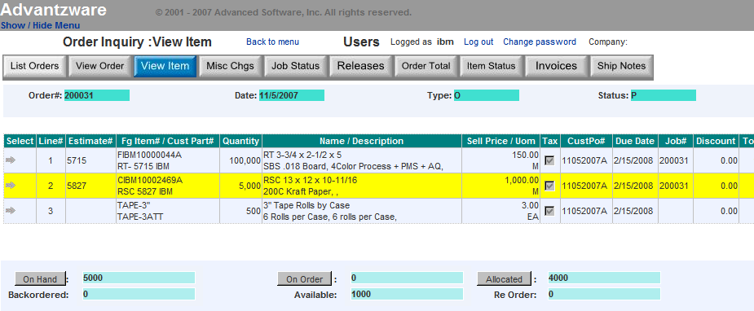

### On Hand

The “***On Hand***” button shows exact quantity on hand of inventory and location for the item selected. This shows the warehouse location, rack or bin location, pallet tag number and total quantity. This also shows if any specific pallet or specific location has been released or if the bill of lading has been processed, thereby alerting the quantity available for future deliveries.

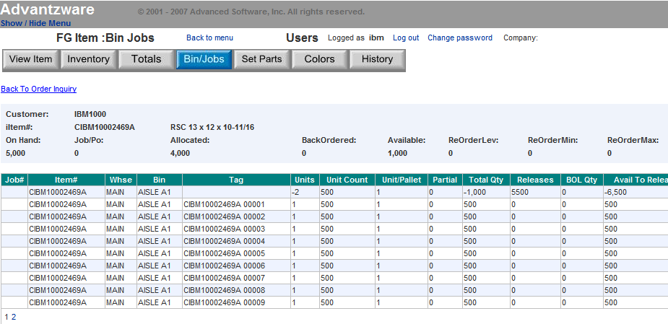

### On Order

The “***On Order***” button shows exact quantity on order and the status of the job including state date as well as the jobs completed date. This also will show the customer’s order quantity, the productions job quantity including overrun, on hand completed, quantity shipped and amount remaining in work in process.

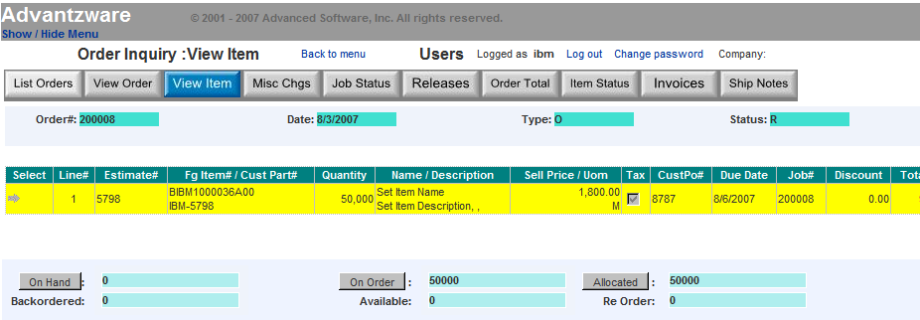

Click the ***“On Order”*** button to drill down to Job Status.

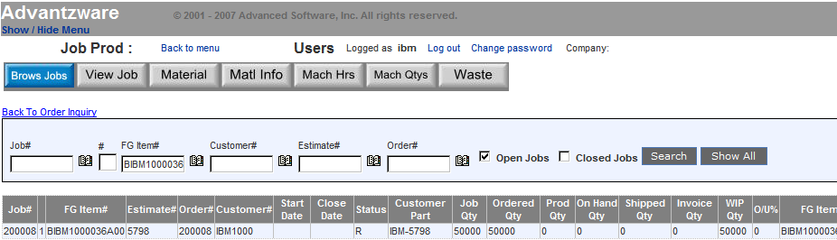

### Allocated

The “***Allocated***” button shows the details of the total order backlog of quantity committed for this item. The item may be on hand, but the quantity of open orders may exceed the on-hand quantity. This inquiry shows which orders have been placed for this item with the appropriate due date, order date and delivery status.

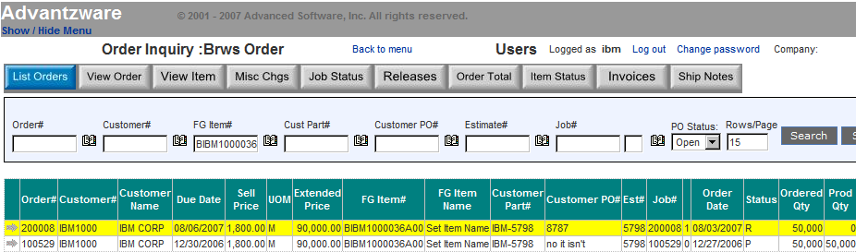

## Miscellaneous Charges

The *Misc. Charges* details all the miscellaneous charges for the order along with the billing status.

Plate charges, die charges, warehousing and other one-time charges related to a specific item on the order is listed for review. In addition, the total estimated weight, freight, tax and order total is listed.

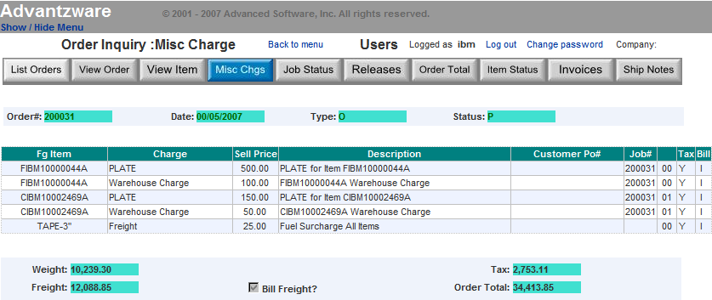

## Ship Notes

Specific shipping notes such as directions and doc times may be defined for each delivery release.

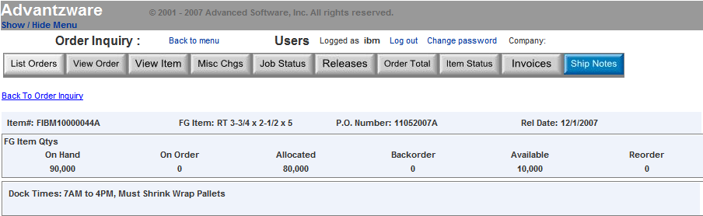

## Order Total

Specific shipping notes such as directions and doc times may be defined for each delivery release.

# **ASI AnyWhere Menu Maintenance**

Through the *Table: Menu Maintenance* screen, the user can add Menu Items.

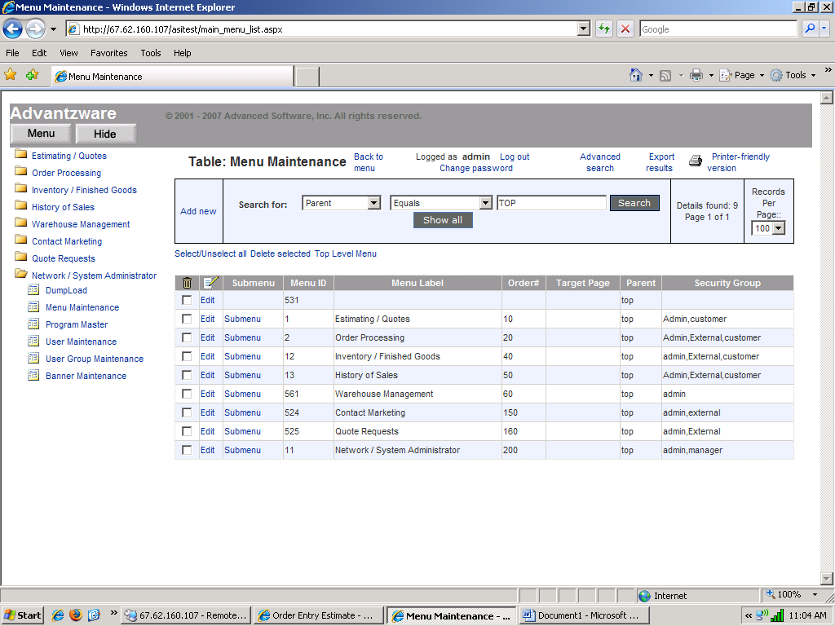

To start this process, the user must click on ***“Add New”.***

## Add New Menu Item

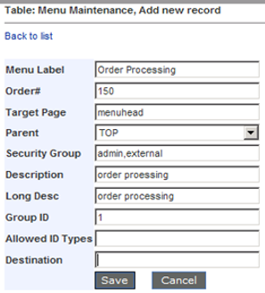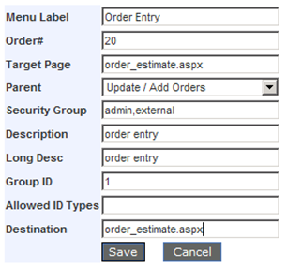

#### Menu Label

The name of the Label we want to show on the menu.

#### Order #

To set the position of the menu label.

#### Target Page

When we give target page “menuhead” it creates the folder which will contain further subfolders for submenus.

Alternatively, the aspx file name which will call on select of that menu item.

#### Parent

To set the parent menu of submenu.

#### Security Group

To set the permission for users to use that menu.

#### Description

To give the Description of menu label.

#### Group ID

This should be always 1.

#### Destination

When the *Target Page* is menuhead then destination should be blank. Alternatively, if using the aspx filename, this will be the same file name as we give on target page.

## Delete a Menu Item

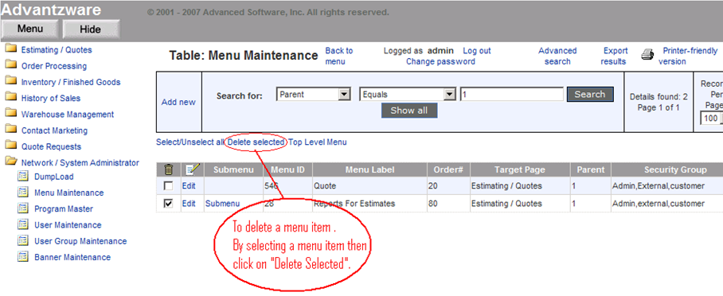

## Dump a Menu Item

To *Dump* a menu item, select *Menu*, and then Dump it on the required path.

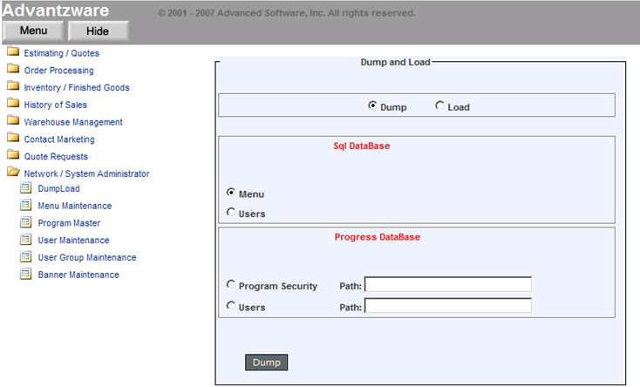

# **ASI AnyWhere: Shopping Cart Application**

This application will run on any mobile device over the internet, however, a bigger screen such as an IPAD or mini tablet is recommended. *ASI AnyWhere* requires the Progress App Server web software, which provides a secure seamless integration to Advantzware orders. In addition, *ASI AnyWhere* allows customers to create releases against orders as well as inquiry into current and past orders, invoices and inventory.

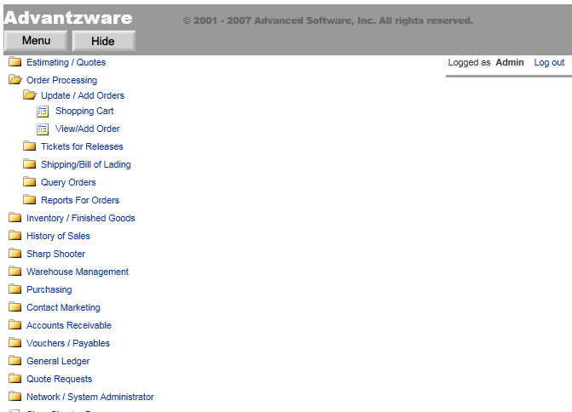

## Order Entry

Orders can be added from an estimate, from a quote or from inventory via the shopping cart application. Login user ID’s are assigned to customers and internal sales representatives. The user ID is assigned specific customer accounts.

In this example, the user IBM logged in an only data for the customer IBM1000 will be available via the application. Internal salespeople will have multiple customers to select, therefore they will use the Book Icon to search for a customer.

Once the customer code is selected, standard order information is displayed as payment type, carrier, payment terms and purchase order number.

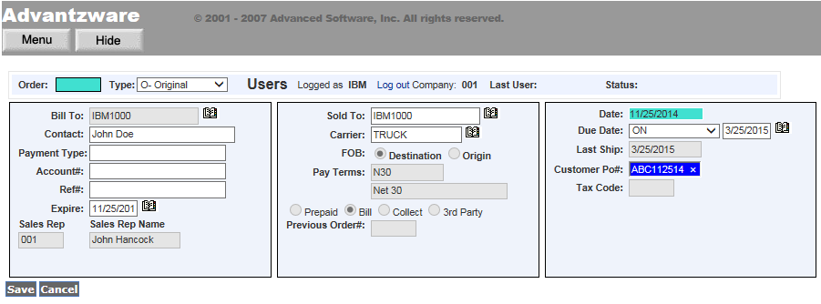

### Order Entry Field Definitions

#### Order

This number automatically starts with the first number in the control file then increments by one for each order added. The order number will also become the first Job Number for this item unless the job number is changed during order entry.

#### Type

Valid entrees are ***"O"*** (Original Order), ***"C"*** (Change) and ***"R"*** (Repeat Order). Original orders for custom boxes create new Finished Goods items in the Finished Goods. ***"R"*** (Repeat) orders or repeat orders with ***"C"*** (Changes) do not create new Finished Goods items. However, they do add to the inventory quantities.

#### Bill To:

Enter the customer’s bill to company name. This transfers to the order when this bill to number is entered.

#### Contact

This field defaults from the customer file. However, the contact may be entered or modified.

#### Payment Type

Payment Method. Enter the type of Credit Card, i.e.: Visa, MC, Discover, etc.

#### Account#

Enter the credit card account number from the credit card.

#### Ref#

You can enter a Reference Number in this space, possibly the approval number from the last time the card was run.

#### Expire Date

Enter the expiration date shown on the Credit Card.

#### Sales Rep

This field defaults from the customer file once a customer number is entered. Up to three salesmen may be entered or modified.

#### Sales Rep Name

This field defaults from the customer file once a customer number is entered. Up to three salesmen may be entered or modified.

#### Sold To:

This defaults to the customer bill to code but may be changed. Enter a Sold To for this customer. The Sold To file provides up to 999 sold to addresses per customer. The sold to name and address may be used for selling to brokers so that the boxes appear to ship from the broker.

#### Carrier

Enter the normal common carrier for shipments to this customer. The carrier entered will automatically transfer to release screen. The system calculates the freight cost based on the total weight of the order quantity by the delivery zones and freight rates matrix defined in the common carrier file in the estimating file maintenance.

#### FOB

This code indicates whether the freight charges begin at your plant or at the customers location.

#### Pay Terms (Part 1/2/3)

Enter a valid terms code from the *Terms* file.

#### Previous Order#

The previous order number defaults from the estimate for repeat orders. Once an order is created, the new order number is written on the estimate.

#### Date

The original date order was created. Defaults to date in system clock. Format is mm/dd/yy and may be modified. This date will also be written to the *Estimate* file.

#### Due Date (Part 1)

Due date codes are used to indicate delivery time frame.

Valid codes are:

|  |  |
| --- | --- |
| BY | By a Specific Date |
| MH | Make and Hold |
| ON | On a Specific Date |
| WK | Have Ready Week Of |

#### Due Date (Part 2)

Enter the date the customer wants the boxes delivered. Format is mm/dd/yy and may be modified.

#### Last Ship

This date is calculated by adding the total number of warehouse days in the customer file to the order date. Format is mm/dd/yy and may be modified.

#### Customer PO#

This field is not required; however, this multiple PO number may be defined for each line item or each release by accessing the Line Item and Release screens. This field is also used for alpha-numeric searches and inquiries throughout the system.

#### Tax Code

Enter a valid sales tax group from the tax file.

## Finished Goods

Finished Goods items are added to the order by searching for an existing quote then selecting a quoted quantity. For stocked items, the quote can be bypassed, and the finished goods item added and followed by the quantity.

The items customer part number, items description, sell price and unit counts immediately transfer to the screen. Additional data such as due date, over and under percentages can be updated prior to saving the line item.

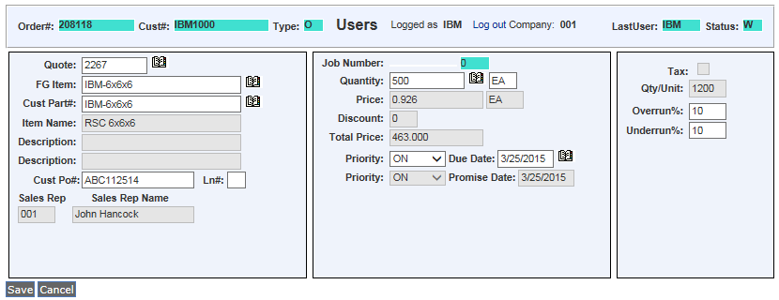

### Finished Goods Field Definitions

#### Order#

This number automatically starts with the first number in the control file then increments by one for each order added. The order number will also become the first Job Number for this item unless the job number is changed during order entry.

#### Cust#

Enter the number of the customer for this receipt.

#### Type

Valid entrees are ***"O"*** (Original Order), ***"C"*** (Change) and ***"R"*** (Repeat Order). Original orders for custom boxes create new Finished Goods items in the Finished Goods. ***"R"*** (Repeat) orders or repeat orders with ***"C"*** (Changes) do not create new Finished Goods items. However, they do add to the inventory quantities.

#### Last User

The username of the last user to have updated this receipt in the system.

#### Status

Order Status Codes are as follows:

|  |  |
| --- | --- |
| A | Approved from Credit Hold |
| C | Closed Order |
| D | Deleted Order |
| H | Credit Held Order |
| I | Invoice Created from Bill of Lading (Ready to Print) |
| N | New Order |
| O | Original Invoice Created from Order (Ready to Print) |
| P | Partially Invoiced Order |
| R | Ready to Release or Ship via Bill of Lading |
| S | Ship Only Invoice |
| U | Updated Order |
| X | Invoice Printed |

#### FG Item

This field links the estimate to Finished Goods item number/s. When entering an order from an estimate that was never ordered, the customer part number defaults to the Finished Good item number, but may be modified. Once the line item screen is updated, the item/s are created in the Finished Goods file and written to the estimate. For repeat orders for that estimate, the same item number would be used rather than creating a new item.

#### Cust Part#

This is your customer's part number for this item. This must be entered on all estimates. The system utilizes the customer part number to calculate the cost of each item based on the blank square inches as a percentage of the total square inches of all items on an estimate. When an order for an estimate is entered, the customer part number will become the Finished Good's item number unless it is modified. Alpha numeric look ups by part number throughout the system are available to find an item, estimate, order or job.

#### Item Name

The description transfers from the Finished Goods file for Stock Items and repeat orders, but transfers from the estimate for new orders from estimates. The item name provides alpha numeric search capability throughout the system.

#### Description (Part 1)

The description transfers from the Finished Goods file for Stock Items and Repeat Orders, but transfers from the estimate description for new orders from estimates.

#### Cust PO#

This field is not required; however, this multiple PO number may be defined for each line item or each release by accessing the Line Item and Release screens. This field is also used for alpha-numeric searches and inquiries throughout the system.

#### Ln# (Line#)

#### Sales Rep

This field defaults from the customer file once a customer number is entered. Up to three salesmen may be entered or modified.

#### Sales Rep Name

This field defaults from the customer file once a customer number is entered. Up to three salesmen may be entered or modified.

#### Job Number

The job number defaults to the estimate number, but may be modified. The Job Factory Ticket will print by job number.

#### Quantity

This defaults to the quantity ordered for the item, however multiple planned releases may be defined immediately.

#### Price

Enter the sell price per unit of measure.

#### Discount

Enter the customers discount percentage off of the sell price. As an alternative, a pricing matrix may be established in the order processing module where prices may set by customer, customer type, product category and item. Price could be based on selling price or discount off of list price in the price matrix file in the order processing file maintenance.

#### Total Price

The total price of the item after discount.

#### Due Date

Enter the date the customer wants the boxes delivered. Format is mm/dd/yy and may be modified.

#### Promise Date

The date the box plant commits to delivering the order.

#### Tax

The total tax, if the customer is taxable, includes all taxable line items as well as miscellaneous charges and freight.

#### Qty/Unit

Enter the number of units.

#### Overrun%

Enter an allowable overrun percentage for this order. This defaults from the customer file, but may be modified. Warning messages will display when this limit is exceeded when entering Finished Goods Receipts & Releases for shipments.

#### Underrun%

Enter an allowable underrun percentage for this order. This defaults from the customer file, but may be modified. Warning messages will display when this limit is exceeded when entering Finished Goods Receipts & Releases for shipments.

# **ASI AnyWhere: Security**

*ASI AnyWhere* gives access anywhere, anytime via an internet connection to customers and outside employees. Menus and submenus may be secured by user login id.

## Define Users and Access Their Rights

The first step to implement *ASI AnyWhere* is to define users and their access rights. External users are limited to what they see and what changes they can make. Whereas an internal user such as an outside salesperson or inside customer service analyst are only limited by security rights. Once defined, the login and password protect your critical corporation information.

Underlying this security is the world-renowned Microsoft SQL database combined with the web security of Progress software’s application server, which allows 25 to unlimited users simultaneous access to information in real time.

Please Note: Do not delete the user group *External*.

Press the keys ***“N” – “U”*** in version 10.0. Click on View User, and then press the Add button on the bottom right. This will allow you to add new users for Advantzware as well as the web. You can use existing users, if already set up in the Advantzware system.

### Saving New Users

Saving new users will require that you press ***“Save”***. The system will then ask you for the Initial Password. Please type this in the box and then press ***“Enter”***.

## Customers and Vendors per User ID

*Web* users are limited to customer and vendor data. The *Customer* folder will limit which customer codes will be available during the use of the *ASI AnyWhere* software. Likewise, the *Vendor* folder will limit which vendor’s information will be available via the *ASI AnyWhere* software. To add Customers for this user ID, press the “***Add”*** button on the bottom of the *Customers* folder. To add Vendors, click the *Vendor* folder and add vendors via the ***“Add”*** button on the bottom.

After you press ***“Add”*** you can then type in the Customer Code or press ***“F1”*** to search for Customers.

If the user ID is for an outside salesperson, then many customers may be entered in the customer folder. If the user ID is an external customer’s employee, then only put their company code here. The menus that display for a user ID are defined in the security in *ASI AnyWhere*.

## Group Maintenance

Now you may log into *ASI AnyWhere* on the internet. You will see the below Login in screen. Simply put in the username and the password we just created. The Login ID and password limits external users to only their customer information. The network security also limits what menu options are available by user.

After signing in you will see the menu to the left and then you must press the Network / System Administrator and then User Group Maintenance. This will allow us to make sure there are the correct groups here and each user that gets put into this system must then be put in one of these groups.

The User Maintenance file will display valid user groups. Press the menu option and select IBM (as an example) by clicking the arrow next to the user’s name. This will highlight this user and you can press View User to change any of their info.

You can then press *Menu Maintenance*, and this will show you the menus that each user group can see and access. You can go even further and allow/dis-allow users certain Submenu options, with a menu. To edit this, you must click in the check box and then press ***“Edit”*** for the menu option you want to edit.

Please Note: Only change the Security Group….